ECE322 Lab 5 –Peak Detector Circuits

I. Introduction
In class we have discussed peak detectors circuits using the constant drop diode approximation. In this lab, we will analyze these structures and simulate their practical performance.

II. Objectives
The objectives of this laboratory are to
- Build and simulate the performance of the simple peak rectifier circuit.
- Build and simulate the performance of the peak detector with superdiode.

III. Motivation
Peak detectors (peak rectifiers) are designed into numerous applications ranging from AM demodulation to detecting signal presence or absence.

IV. Materials
The materials for this laboratory will include the LTSpice simulator and models for the 1N4148 diode and LM324 opamp components and lab bench equipment and prototyping parts. Use opamp supplies of +/-10 Volts. Export data from LTSpice to overlay with the experimental data in EXCEL.

V. Lab – Circuit Investigation

- Simple peak detector

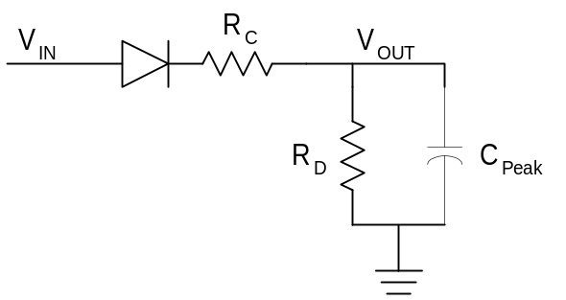

Figure 1. Peak Rectifier Circuit

For the circuit of Figure 1, run a Spice transient simulation with R_{C}=200, R_{D}=100K, and C_{Peak}=0.1uF. Apply an input sin wave with peak-to-peak amplitude of 4Vpp at 1kHz. Run the transient for 5mS.
B. Peak detector with superdiode structure analysis and simulation

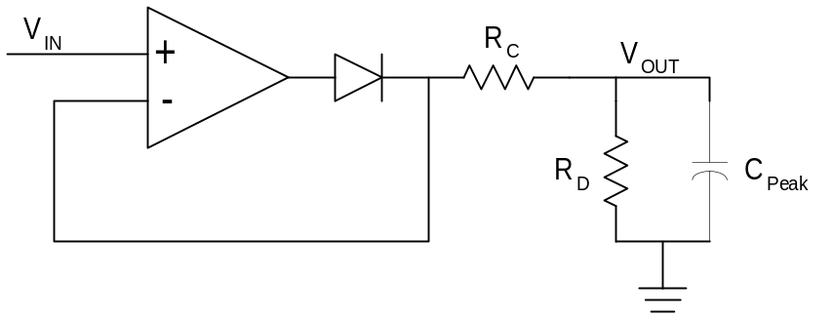

Figure 2. Peak Detector Circuit

For the circuit of Figure 2, perform a Spice transient simulation with R_{C}=200, R_{D}=100K, and C_{Peak}=0.1uF. Apply an input sin wave with peak-to-peak amplitude of 4Vpp at 1kHz. Run the transient for 5mS. Use opamp supplies of +/-10Volts.

VI. Summary

Pull your lab together in a 2 page or less memo, overlaying experimental and simulation results and brief explanations of circuit operation.

